**CSE 471(SEC-03)**

**Course Name: System Analysis and Design**

**Title of the Project: BLOOD BANK MANAGEMENT SYSTEM**

**Group Number: 03**

**Group Name: Team Thanos**

**Submitted by:**

|  |  |
| --- | --- |
| **Name** | **ID** |
| **MD. AOSAFUL ALAM** | **16101061** |
| **SHAHAN JAMIL BUIYAN** | **16101091** |
| **NAZMUS SAKIB AKASH** | **16101208** |
| **ASHRAFUL JANNAT** | **15101102** |

**SEQUENCE DIAGRAM**

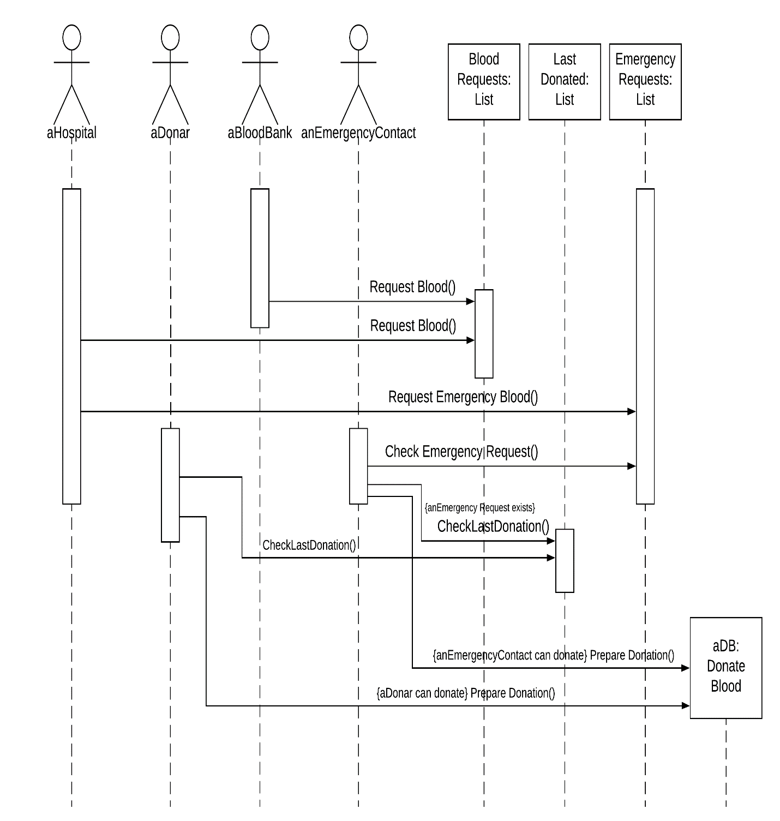

**BEHAVIORAL STATE MACHINE DIAGRAM**

